Information Request to prepare Children Ministry Family List (single or couple information)
Navan Community Sunday School, Navan Youth Group and Camp Awesome are programs sponsored and supported by St. Mary’s Anglican Church and Navan-Vars United Church.
Name________________________________Name____________________________
Address________________________________________________________
________________________________________________________________
Email Address __________________________________________________
Email Address__________________________________________________
Phone _______________________ Mobile Phone ____________________
Phone _______________________ Mobile Phone______________________
Do you have a connection as a former student, volunteer, or parent of children who attended any of the following groups? Please X any of the following you and/or your children have been part of:
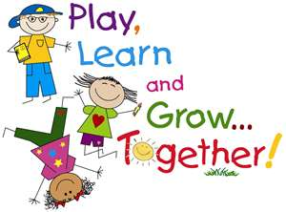
Navan Community Sunday School _______
Navan Youth Group ________
Camp Awesome___________

Please list the name(s) and age(S) of your children who would be interested in attending any of the above groups. If they are under 4 years of age – please add their name and age so we add them to our family list.
_________________________________________________________________________________________________________________________________________________________________________________________________________________________________________
Please return information to: Email either
Shelley Douglas: shelley.douglas56@gmail.com or Jill Noakes: jillnoakes@hotmail.com
Information can also be drop off at 3522 Trim Road, Navan.
Call Shelley at 613-835-3965 with any questions or concerns.

LET US KNOW IF YOU WOULD LIKE YOUR NAME REMOVED FROM THIS LIST. THANK YOU.
This is not a registration list and will not be shared.

